***Project 2:***

1. ***Create 2 stacks one for Netwok and the other for infrastructure services***

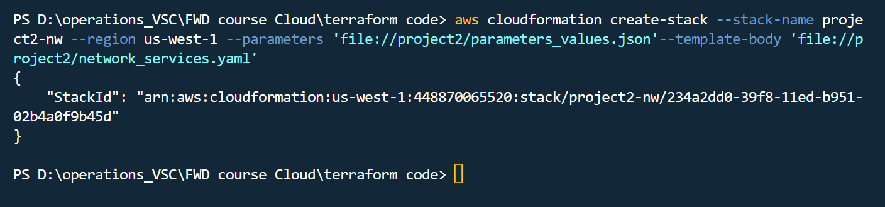

***{***

***"StackId": "arn:aws:cloudformation:us-west-1:448870065520:stack/project2-nw/234a2dd0-39f8-11ed-b951-02b4a0f9b45d"***

***}***

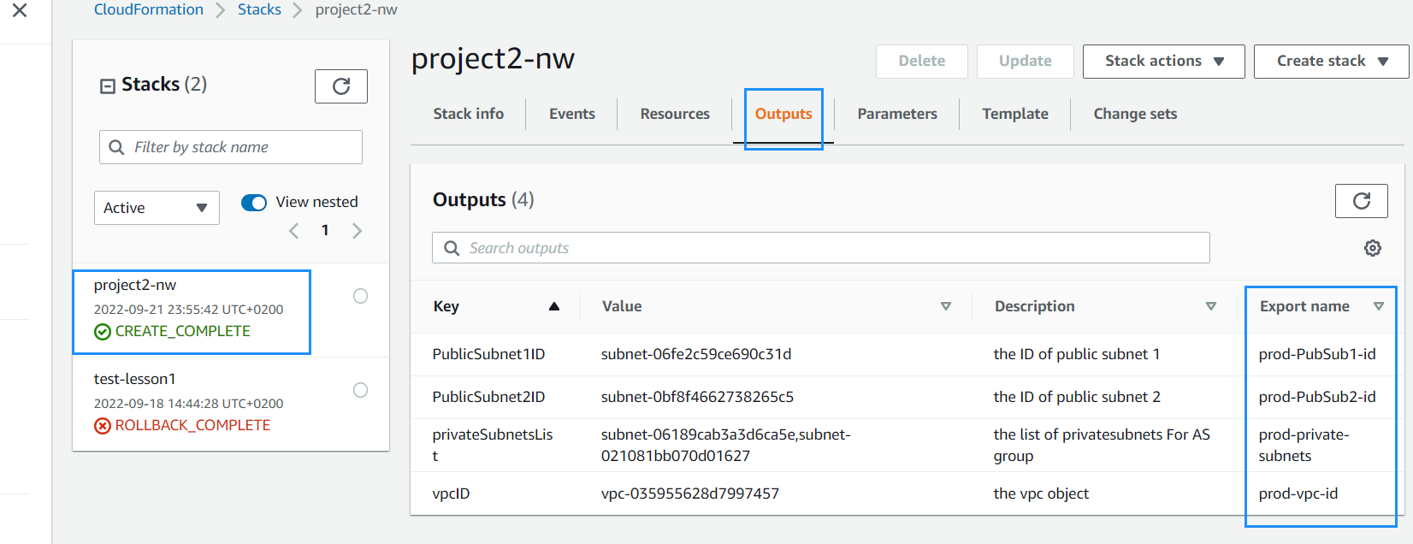

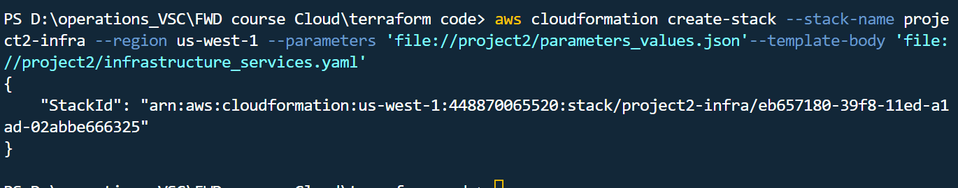

***{***

***"StackId": "arn:aws:cloudformation:us-west-1:448870065520:stack/project2-infra/eb657180-39f8-11ed-a1ad-02abbe666325"***

***}***

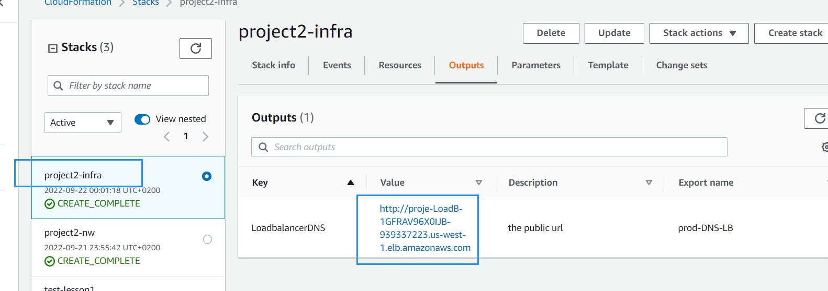

1. ***Website working***

